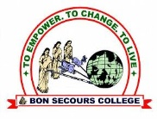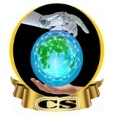BON SECOURS ARTS AND SCIENCE COLLEGE FOR WOMEN.

**(Affiliated to Mother Teresa University, Kodaikanal)**

**Madurai main road, Begampur (PO), Dindigul – 624 002.**

DEPARTMENT OF COMPUTER SCIENCE

**Date:**28.06.2024

CO - TECH FEAST ASSOCIATION

**Report – Student Development Program on “ Tech Designing”**

The Department of Computer Science had organized astudent development program on “ Tech Designing” in phenomenal way. We had planned to enrich the students imagination skill and creative skill in designing using canva. We taught them the designing and animation using canva. Dr. M. Guhapriya, Head, Department of Computer science had delivered a short introduction about demand of tech. And with the guidance of staff the event were conducted by the second and third year students of Computer science. We were conducted the event in three batches.

First batch (9.30 am to 10.30 am)–I BSC CS, I BA English, I BSC Mathsand I BCA.

Second batch (10.30 am to 11.30 am) – I BSC Chemistry, I B.Com and I BA Tamil.

Third batch (11.45 am to 1.00 pm) – I B.Com CA and I BBA.

The event featured excellent collaboration, originality, and commitment from the teachers and students with well thought-out attractive design and animation using canva. The feedback from the students were collected through Google form.

**Enclosures :** 1. Student sample creation

2. Photos

3. Feedback form

**STUDENT’S SAMPLE CREATION**

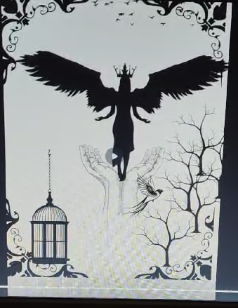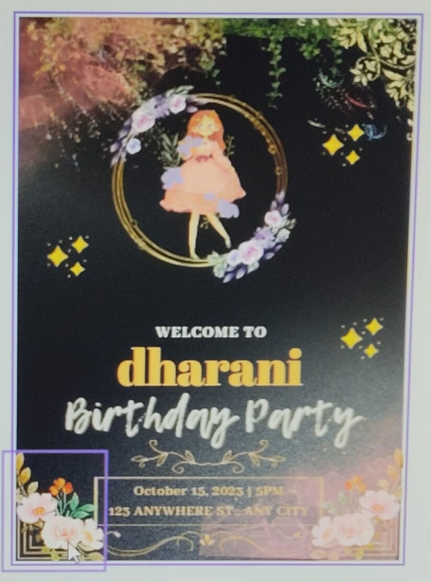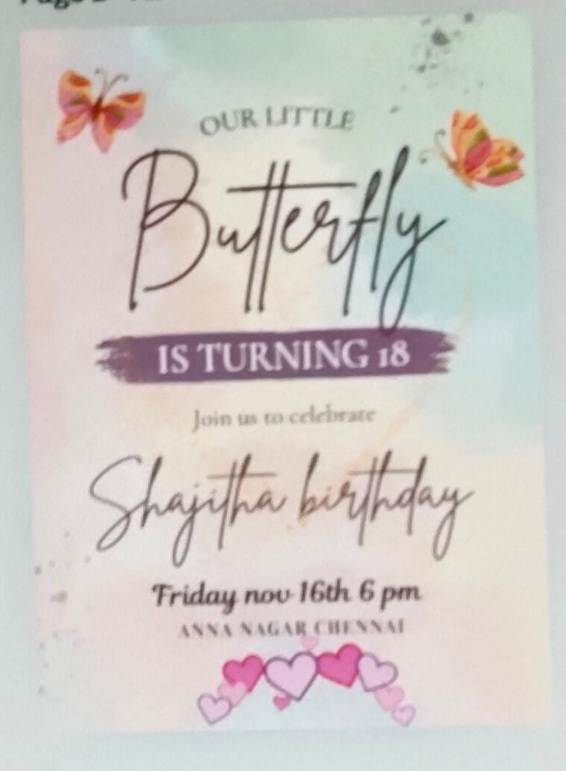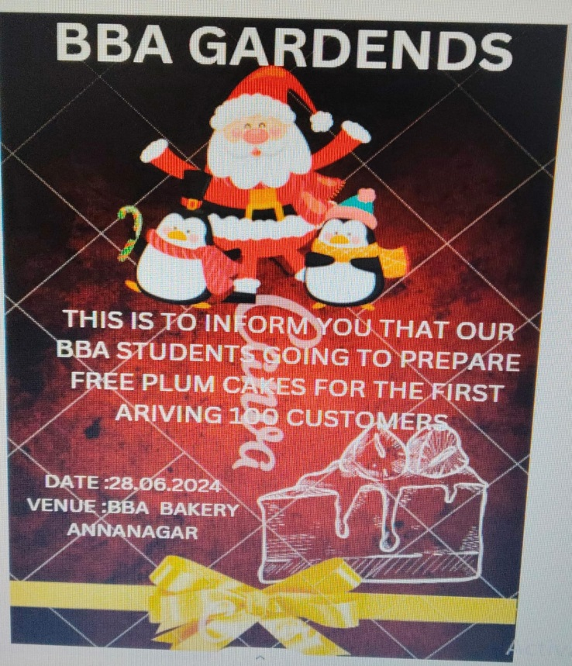

**PHOTOS –SDP ON “TECH DESIGNING”**

